A critical analysis of teaching and learning negative numbers

Anna Bellamy

Gloucestershire College, United Kingdom
anna.bellamy @ gloscol.ac.uk

My enthusiasm for mathematics was based principally perhaps on my horror of hypocrisy; hypocrisy as I saw it, was my aunt Séraphie, Mme Vignon and their priests. In my opinion hypocrisy wasn’t possible in mathematics and, in my youthful simplicity, I thought the same went for all the sciences in which I had heard it said they were applied. What then when I realized that no one could explain to me how it is that a minus times a minus equals a plus?
(From The Life of Henry Brulard, pseudonym for Marie-Henri Beyle, better known as Stendhal,1890, ed. 2002, pp. 363–364)

- What do you teach?
- Children. I teach children.

When I first decided to write about negative numbers, it was purely because of my personal experience of teaching and learning this topic. Despite having examined numerous resources and discussed them with other teachers (both primary and secondary, with varying levels of experience), I was still to find a way of teaching negative numbers that would be both intuitive and mathematically correct, whilst avoiding referring to any axioms, be it directly or indirectly. During my research, I came to the conclusion that the main challenge in introducing negative numbers lies not in broadening the number system, but in (re)defining the four basic operations: addition, subtraction, multiplication and division. The intuition that children have developed in primary school regarding calculation must be de- and then re-constructed in order to introduce negative numbers. This is perhaps the very first time that the students will have this type of experience in their mathematics education – instead of building on their prior knowledge and developed intuition, students are being told that what they have learnt so far is not *quite* true (or true only under certain circumstances). According to Skemp (1971 p116), “The student has no need to accept anything which is not agreeable to his own intelligence – ideally he has a duty not to”. This paper is an attempt to dissect the teaching and learning of negative numbers to KS3 students – and then reconstruct the methods currently used so as to create a comprehensive, accurate and accessible way of introducing negative numbers at KS3. This will mean that the student will gain a true understanding of the number system, rather than relying on rules such as “two minuses make a plus”.
4b. Multiplication:
partitioning: (opposite to aggregation in adding, refers to cardinal aspect of number) - one set is split into two discrete sets
reduction: (opposite to augmentation in adding, refers to ordinal aspect of number, counting back) - reduction in size of one set
comparison: compare
In my research, I looked into numerous sources from several disciplines, namely:
- the experience of classroom practitioners
- primary and secondary school textbooks
- higher maths textbooks
- the philosophy and history of mathematics
- the methodology of teaching mathematics
- child development and psychology
- cognitive science
This, I believe, has enabled me to construct a wide-ranging critical analysis of current debates surrounding the teaching and learning of negative numbers.
I will start by briefly looking into the knowledge that students gain about negative numbers outside of school. Then, I will analyse the concept of integers and identify the success criteria students must meet to truly comprehend all four arithmetic operations. Illustration 1 is intended to supplement and support this analysis.
I will subsequently move on to an analysis of the current methods and models used to teach negative numbers. This will lead me to a final section on proposed improvements to teaching negative number at the policy level. I will include both proposed improvements to current classroom methods and my own classroom practice throughout this paper.
The map of concepts I will discuss in this paper is available as Illustration 1 “Mapping the minefield”. Not all the identified factors will be discussed in great detail in this paper - however, their presence on the scene must be acknowledged for the sake of consistency and creating a full picture of the cognitive challenges students encounter when dealing with negative numbers.

Before secondary

In students’ daily experiences, a sum of two elements is always bigger than the both of them. The difference between two numbers is the same whether we talk about “the difference between £5 and £12” or “£12 and £5”. The negative numbers come only in contexts of scales, like a temperature scale, or underground car park levels. It is worth noting that Year 3 children are able to solve simple contextual tasks involving negative numbers (e.g. temperature rise/drop) as long as said problems are presented using words and not formal notation (Haylock 2005).

Prior to encountering negative numbers, children will be taught that:
“=” means an instruction to perform a task,
“+” and “-“ mean an operation, an information as to what task needs performing: 2+3 or 9-2.
However, we will expect them to learn that:
“=” indicates an equality between two concepts, and
“+” and “-“ represent not only an operation, but also an aspect of the number – and that said aspect can change the nature of an operation. (Additionally, said operations have several different structures each). This is a very big challenge conceptually speaking, and the language confusion increases it greatly (Beswick 2011). Referring to -5 as negative 5, rather than minus 5, may help on the context of the classroom, however the students will have heard negative temperatures read as minus 5, so the question remains whether this strategy is helpful (ibidem).

Success criteria

If a student is to gain a relational understanding of negative numbers, they first need to be aware of the different meanings a number can carry, especially the ones related to counting and measurement. Ideally, they would also understand, and be able to apply, different constructions of all 4 operations (see boxes 3 and 4, Illustration 1). This is obviously a lot to ask for, especially of Year 7 students.
Once the two are accomplished, we need the student to separate the attribute of the number and the operation, which requires a greater level of abstraction in understanding both the operation and the attribute of the number. This can be illustrated as:
For natural numbers:
a type of operation ⇒ rise OR fall
whereas, for integers:
(a type of operation) ⊕ (an attribute of the number) ⇒ rise OR fall.
This is a great leap in the understanding of numerical operations, especially if a child still relies on counting on/back for additional and subtraction (and many Year 7 students do). In my classroom practice, I used the following example to illustrate this issue for my students:
Teacher: What does a fridge do?
Students: It chills food!
Teacher: So it makes it colder?
Students: Yes!
Teacher: Always?
Students: Always!
Teacher: So, if I put a cup of tea into the fringe, it will get colder, right? But what if I had a frozen chicken and put in into the fridge? What would happen then?
This example got students to think about the combination of an operation (fridge cooling things down) and the attribute of the number (boiling tea, frozen chicken) and how the final effect depends on both these factors.
The counting-on strategy, based on the number line concept, refers strictly to an ordinal aspect of a number and therefore the augmentation structure of addition (Illustration 1, box 4). Consequently, the further leap in the conceptual understanding comes in the form of extending the student’s way of thinking to include aggregation as a structure of addition and partitioning for subtraction.
This in turn brings a need for further extension of a child’s strategies of problem-solving. As Nesher and Teubal (1975) showed, when presented with a worded problem, children look for key words (like “more” or less”) and base their solutions on these prompts, rather than trying to analyse the logical structure of the problem. If the question contains the word “more” and requires addition, 87% of children are successful; however, if the question contains “more” but requires subtraction, the success rate drops to 43%. Why does it create a minefield when negative numbers are added to the number system? Because we (inexplicitly) ask children to adjust their problem solving algorithms by going from “step by step procedures to rich knowledge of network concepts” (Meadows 2006, p.79). This can be illustrated as follows:

The starting point (many children skip the analysis stage altogether):
Logical problem analysis formal representation calculation solution

The end point:
Logical problem analysis formal representation analysis calculation solution

If a formal representation includes negative numbers, a student will have to analyse to it be able to find the final answer. It is my theory that this additional step creates increased difficulty for a lot of students when they are faced with worded tasks that include negative numbers, as students will have to involve their analytical thinking twice – first to represent the problem and then to analyse its formal representation to be able to perform the calculation. This can be at least partially supported up by Beswick (2011) who claims that children will avoid negative numbers in formal representation whenever possible.

Review of current methods and models used to teach negative numbers

Aside to the range of teaching methods employed in the classroom, every student (should) have access to additional materials like textbooks, homework books and reference books. Illustration 2 demonstrates a choice of methods from several popular publications. It is quite interesting to see that neither of the books explain the rules they provide the students with. In Picture E, Illustration 2 an amoeba (representing a student) claims: “I always get confused when I use negative numbers. I am starting to feel like I’ll never understand them. Are there any rules I can use to help me?”. It would be beneficial if the student was then provided with a further explanation on negative numbers, rather than rules to use them.
This is unfortunate as if, for whatever reason, the classroom explanation does not satisfy student’s curiosity, a textbook could be the next step. I could not find a standard textbook that would present a convincing argument to Year 7 students why it is that “two minuses give a plus”.

Weather forecast, multi-storey car park and bank balance

Introducing negative numbers often starts with the temperature scale – students will have already been familiar with negative temperatures and it seems to be a great way of providing the context that is both “familiar and transferable” (Beswick 2011). According to Beswick’s and also Altiparmak and Ozdogan’s study (2008), both progress and achievement are significantly better if students encounter non-formalised ways of using negative numbers first. However, it has been known from previous research (Haylock 2005) that primary school children are able to perform basic operations on negative numbers with very little, if any, guidance. The question therefore arises: when using a scale model to introduce negative numbers, are we in fact developing children’s mathematical skills, or just their numeracy? Both are important of course, but not equally beneficial to children’s understanding of negative numbers.
Additionally, using the temperature scale as a teaching model is very limited – it lets us introduce adding and subtracting of integers, but not multiplying and dividing. A similar problem would occur if just a number line was used instead.
Using bank statements as a teaching model has less limitations in terms of arithmetic operations. For example, we can introduce the idea of sharing a debt equally between several people. It could also have the added benefit of using “real life” examples in the classroom, including actual bank statements. The main challenge in using this model lies in two underlying presumptions: (1) that children comprehend the idea of a debt and that the concept is secure, and (2) that children know how to read a (simplified) bank statement. A model that is very similar to using banking, but lacks its disadvantages, is a game developed by Liebeck (1990) called Scores and Forfeits. It is a simple card game with different values being assigned to cards. Keeping a running total requires (inexplicitly) adding and subtracting integers. It is a model that develops children’s intuitive understanding of negative numbers. However, the challenge remains: how do we help the students to move from intuitive approaches to a conceptual understanding and then a mathematical representation? The main method currently in use involves using the number line, which is discussed in good detail below.

Number line

The number line, so common in the classrooms in Britain, is just a model, and as such, certain aspects of what is being modelled are represented, but others are omitted. The number line is a static model and an ability to perform operations based on this model is fairly limited, especially when it comes to multiplication and division. However, it must be noted that it can be extremely useful for adding and subtracting. Beswick (2011) developed a teaching activity that involved an oversized number line and students physically moving up and down the line, the direction of movement and the way they were facing being dependant on the operation and the sign of the number. This is a prime example of good practice that actively involves kinaesthetic learners.
My main concern regarding the number line is that it represents only the augmentation structure of addition – in other words, an operation is always performed on only one set, and the result is also represented on the very same number line. Additionally, children are taught in primary school that larger numbers are further away from 0, which of course does not stand for negative integers. The concept of modulus is not being introduced in KS2 nor KS3, which could somehow rectify the issue with children identifying the number as its distance from 0. Heeffer (2001) and Gallardo (2002) both claim that negative numbers should be taught in a strictly algebraic context and not with the help of the number line which can be misleading. Heeffer provides a historic argument – it took several hundred years and struggles of such great minds like Leibniz, Euler and d’Alemebert to fully understand the meaning behind negative numbers. Nowadays, children in Year 7 are expected to perform multiplication and division on negative integers as a symbolic calculation. Heeffer argues that we simply teach the children rules of arithmetic and they gain no real understanding of negative numbers at this stage. Additionally, Gallardo brings an argument of negative numbers as solutions to linear equations – up to the XVI century such an idea was seen as pure nonsense (analogous to a square root of a negative number – we do not, however, teach about imaginary numbers in KS3!)
Given the above, the question occurs: are the negative numbers as described by Heeffer and Gallardo (and used by mathematicians) even the same concept as that which we teach to KS3 students? The Celsius scale was originally invented in inversed form (0 being the boiling point of water and 100 – the freezing point). The negative numbers were added to the scale only later on, as the scientific world adopted the scale. The concept of debt and the mathematical principles guiding it had been known since the VII century. However, the abstract operations on negative numbers had not been incorporated into the mathematical world till the XVII century. Would it be inappropriate to claim that our approach towards teaching negative numbers at KS3 is comparable to trying to teach our students to understand Shakespeare by means of providing them with extracts form Hello magazine?
Based on my experience at school so far - given how familiar my students were with the number line - I would like to extend this concept for natural numbers before moving on to negative numbers by introducing adding and subtracting using 3 number lines instead of one. It may sound slightly eccentric, however it would help to secure the aggregation structure of adding by representing both components as separate sets, and the sum of the components as a new set.

Events

One of the more interesting models of teaching integers is to use the numbers to represent (reversible) events, rather than quantities of physical objects. It was originally introduced by Richard Skemp in The Psychology of Teaching Mathematics (1971). I find this model particularly agreeable as it does not oversimplify the negative numbers. Doing something once is represented by 1. Undoing something once is represented by -1 etc. This is based on (and represents) the very practical idea that to undo something, an equal and opposite act has to be done. This model makes multiplication of negative numbers possible to explain however it also relies on an abstract concept of doing “something” and also an ability to identify “an equal and opposite act”. This can represent a challenge for Y7 students – therefore, if this model were to be implemented in the classroom, it would have to be done within very precisely defined parameters. (There also arises a philosophical question of whether I can undo something more times than I did it in the first place, which could potentially make the model too complicated for the majority of KS3 students – it could however be used as an extension tor the G&T students).

Number work

As we have seen so far, providing an explanation for adding and subtracting integers is fairly easy within daily life contexts. It is division and multiplication, especially of two negative numbers, that causes problems. Cardano’s idea of finding an area of a square (Heeffer 2001) can be adopted to represent the very same process using a grid method, which most of Y7
children should be familiar and confident with:

- We start by claiming that 5x 5 = 25
- Given that 5 = 4+1:

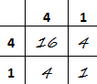

- Then, we claim that 4 x 4 = 16
- 4 = 5 - 1, therefore:

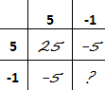

We know that 4 x 4 = 16 and that 25 – 5 – 5 = 15. Therefore, (-1) x (-1) must equal +1 for this equality to be true.
This method is the simplest way of proving that (-1) x (-1) must equal +1 that I have seen so far and I believe it would be accessible to both late KS2 and early KS3 children.
It has also occurred to me that another way of showing that a product of negative numbers is always positive would be by the means of using the scale factor. (an asymmetrical object enlarged by SF -2 and then -3 would look the same as if it was just enlarged by SF6. It would make for a great project lesson and hopefully lead to some discovery and investigative learning. It could be further extended to teaching fractions multiplication).

I mentioned before ((p.3, Before secondary) that children have a common misconception that adding makes things bigger and subtracting – smaller It has also been showed that early KS3 students rely heavily on ‘counting on’ (Meadows 2006), which in turn makes their concept of addition very augmentation-centric. Both these facts combined make any arithmetic operations with negative numbers challenging to the students. I propose that before we even consider moving on to negative numbers, or fractions for that matter, it would be worth broadening the student’s understanding of addition.
In terms of conceptual change, we would need to take them from this:
For any A + B = C, C must be bigger than both A and B
to this:
For: A + B = C and A + D = E, if D is greater than B then E is greater than C.
This would require looking at a friendly series of natural numbers – the goal of this activity would be to ensure that the students see an operation in the context of other similar operations (instead of seeing an operation in the context of one of its elements only).
This in turn would mean that the students would not need an entirely new set of rules for negative and positive numbers, or fractions. (Alibali and Prather 2007), but could simply apply their knowledge to the new numbers being introduced. This however is based on the very strong presumption that the students would know that (1) negative numbers are smaller than natural numbers, and that (2) the further away the negative number is from 0 the smaller it is. This is a very counter-intuitive process, albeit it can be learnt if practiced enough, as shown by Pinhas and Tzelgov in their 2012 article about the cognitive representation of zero. The study was conducted to identify the structure of a mental number line under automatic processing, and therefore with no conscious processing effort on the subjects’ side. The study discovered three very interesting facts, especially from a mathematics teacher’s perspective:
- The mental number line starts at 0 and does not extend to the left beyond 0
- 0 is perceived as a lack of quantity, not a quantity itself (so not an attribute of an empty set, but the lack of a set altogether)
- And most importantly: “when negative numbers are physically compared, the absolute numerical values are automatically processed and the polarity signs are ignored ”, (…) which supports the theory that the negative numbers are presented in terms of their components” (ibidem, p. 1188)

What does it mean from a teaching point of view? It is a nature vs. nurture argument, as the very same study showed that the brain can be “trained” to process negative numbers in a mathematical way. (It is worth knowing that only numbers from 1 to 9 are easily processed by the brain. Aside to negative numbers, two digit numbers and fractions also require the brain to be “trained”).
The table below (Table 1) shows the main teaching methods described so far and whether they can be used for explaining/proving the underlying rules of arithmetic with integers

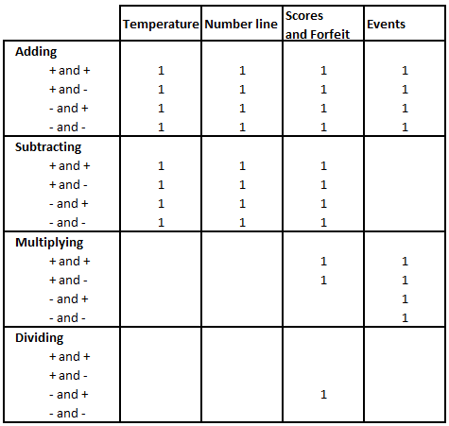

Table 1: The main teaching methods and their usefulness. The first column lists four arithmetic operations performed on different combinations of positive and negative numbers. “1” in the main body of the table indicates that the teaching method, listed in the top row, can be used to at least convincingly show (if not prove) the rules of the operations on integers.

What next?

There are many different ways of teaching negative numbers; see table 1. By using a combination of these methods, it is possible to secure a functional understanding of negative numbers by KS3 students. However, the question that has not been answered so far lingers on: why do we need to teach them to this extent in the first place? This initially sounds like a menacing type of question that would be asked by a lazy, narrow minded teacher, but consider this:
From the numeracy point of view, students must be familiar with negatives to the extent demanded by natural sciences, which in practice means using a variety of scales (temperature, metres above/below the sea level). If we include so-called real life skills, the students must be able to apply their knowledge about integers to bank statements and financial transactions. As shown by Haylock (2005), children in Year 3 have sufficient mathematical intuition to be able to perform all these operations without the need for formal mathematical language. Is it enough to say that teaching negative numbers and all 4 operations on integers in KS3 is pointless? No, of course not. Where my doubts about teaching negative number in all its glory to Year7 students originate from is in fact this: I do not believe that at KS3 it can be taught as an independent unit and be taught well.
This could be solved by incorporating teaching negative numbers throughout year 7, with various operations on integers being introduced when handy modelling situations arise (reading temperature, scale drawings, translation, lessons on ethics and mathematics). It would let effortlessly associate meaning to negative numbers and the arithmetic rules would come up naturally, rather than being forced upon unsuspecting children in the form of a rule to follow.
In the current state of affairs, teaching negative numbers is the very first time when we tell students “Here’s the rule, follow it, ignore your intuition” and hope for the best. Given that it often happens very soon after the primary/secondary transition, I think this has a great potential to damage students’ attitudes towards the subject, especially for more able children – mathematics should not and does not require following artificial rules, this is the best part of it?
There is one more development that would greatly enhance the teaching of negative numbers – namely introducing basic set theory to the KS3 curriculum, preferably immediately after transition from the primary school. Union of sets or intersection of two sets is not inherently difficult, but it would help the students to think about mathematics beyond counting and measurement. If I could ask the curriculum fairy for one more favour, I would mention a unit on (very) basic logic sometime at the beginning of Y7 too.
As I reflect on my own practice, it often surprises me how much of a rebellious purist I have become – I have a strong passion for introducing social justice into my classroom, and I knew it would be the case given my previous academic study and personal experience. However, what I did not expect was the constant striving to teach my students the “real” mathematics – the beautiful way of thinking, not the set of rules to follow. Teaching negative numbers made me realise that it is not only social, but also mathematical justice I want for my students. And nothing less will do.

Bibliography

Alibali, M.W. and Prather, R. W, (2008) Understanding and Using Principles of Arithmetic: Operations Involving Negative Numbers, Cognitive Science, April, Vol. 32 Issue 2, p445-457
Altiparmak, K. and Özdoğan, E. (2010) A study on the teaching of the concept of negative numbers, International Journal of Mathematical Education in Science & Technology, Vol. 41 Issue 1, p31-47
Beswick, K. (2011) Positive Experiences with Negative Numbers: Building on Students in and out of School Experiences, Australian Mathematics Teacher, Vol. 67 No. 2, p31-40
Gallardo, A. (2002) The extension of the natural-number domain to the integers in the transition from arithmetic to algebra, Educational Studies in Mathematics, Vol. 49 Issue 2, p171-192
Grayson, A. and Oates, J. (2004) Cognitive and language development in children, Milton Keynes: The Open University Press
Haylock, D. (2005) Mathematics explained for primary teachers, London: Sage
Heeffer, A. (2011) Historical Objections Against the Number Line, Science & Education, September, Vol. 20 Issue 9, p863-880
Liebeck, P. (1990) Scores and forfeits: an intuitive model for integer arithmetic, Education Studies in Mathematics, 29, p221-239
Londsdale (2009) Complete KS3 Maths Course book, Bishopbriggs: Letts
Meadows, S. (2006) The child as thinker, Hove: Routledge
Nesher, T. and Teubal, E. (1975) Verbal clues as an interfering factor in verbal problem-solving, Educational Studies in Mathematics, Vol. 6 p41-51
Pinhas, M. and Tzelgov, J. (2012) Expanding on the Mental Number Line: Zero Is Perceived as the “Smallest”, Journal of Experimental Psychology. Learning, Memory and Cognition. September, Vol. 38 Issue 5, p1187-1205
Pledger, K. (ed) (2008) Level up series (3-8), Harlow: Heinemann
Skemp, R. P. (1971) The Psychology of Learning Mathematics, Harmondsworth: Penguin books Ltd
Usborne Dictionaries (2010) Junior illustrated maths dictionary, London: Usborne Publishing Ltd
Vorderman, C. (2010) Help your kids with maths, London: Dorling Kindersley
Zaccaro, E. (2002) Real world algebra, Bellevue, Iowa: Hickory Gove Press

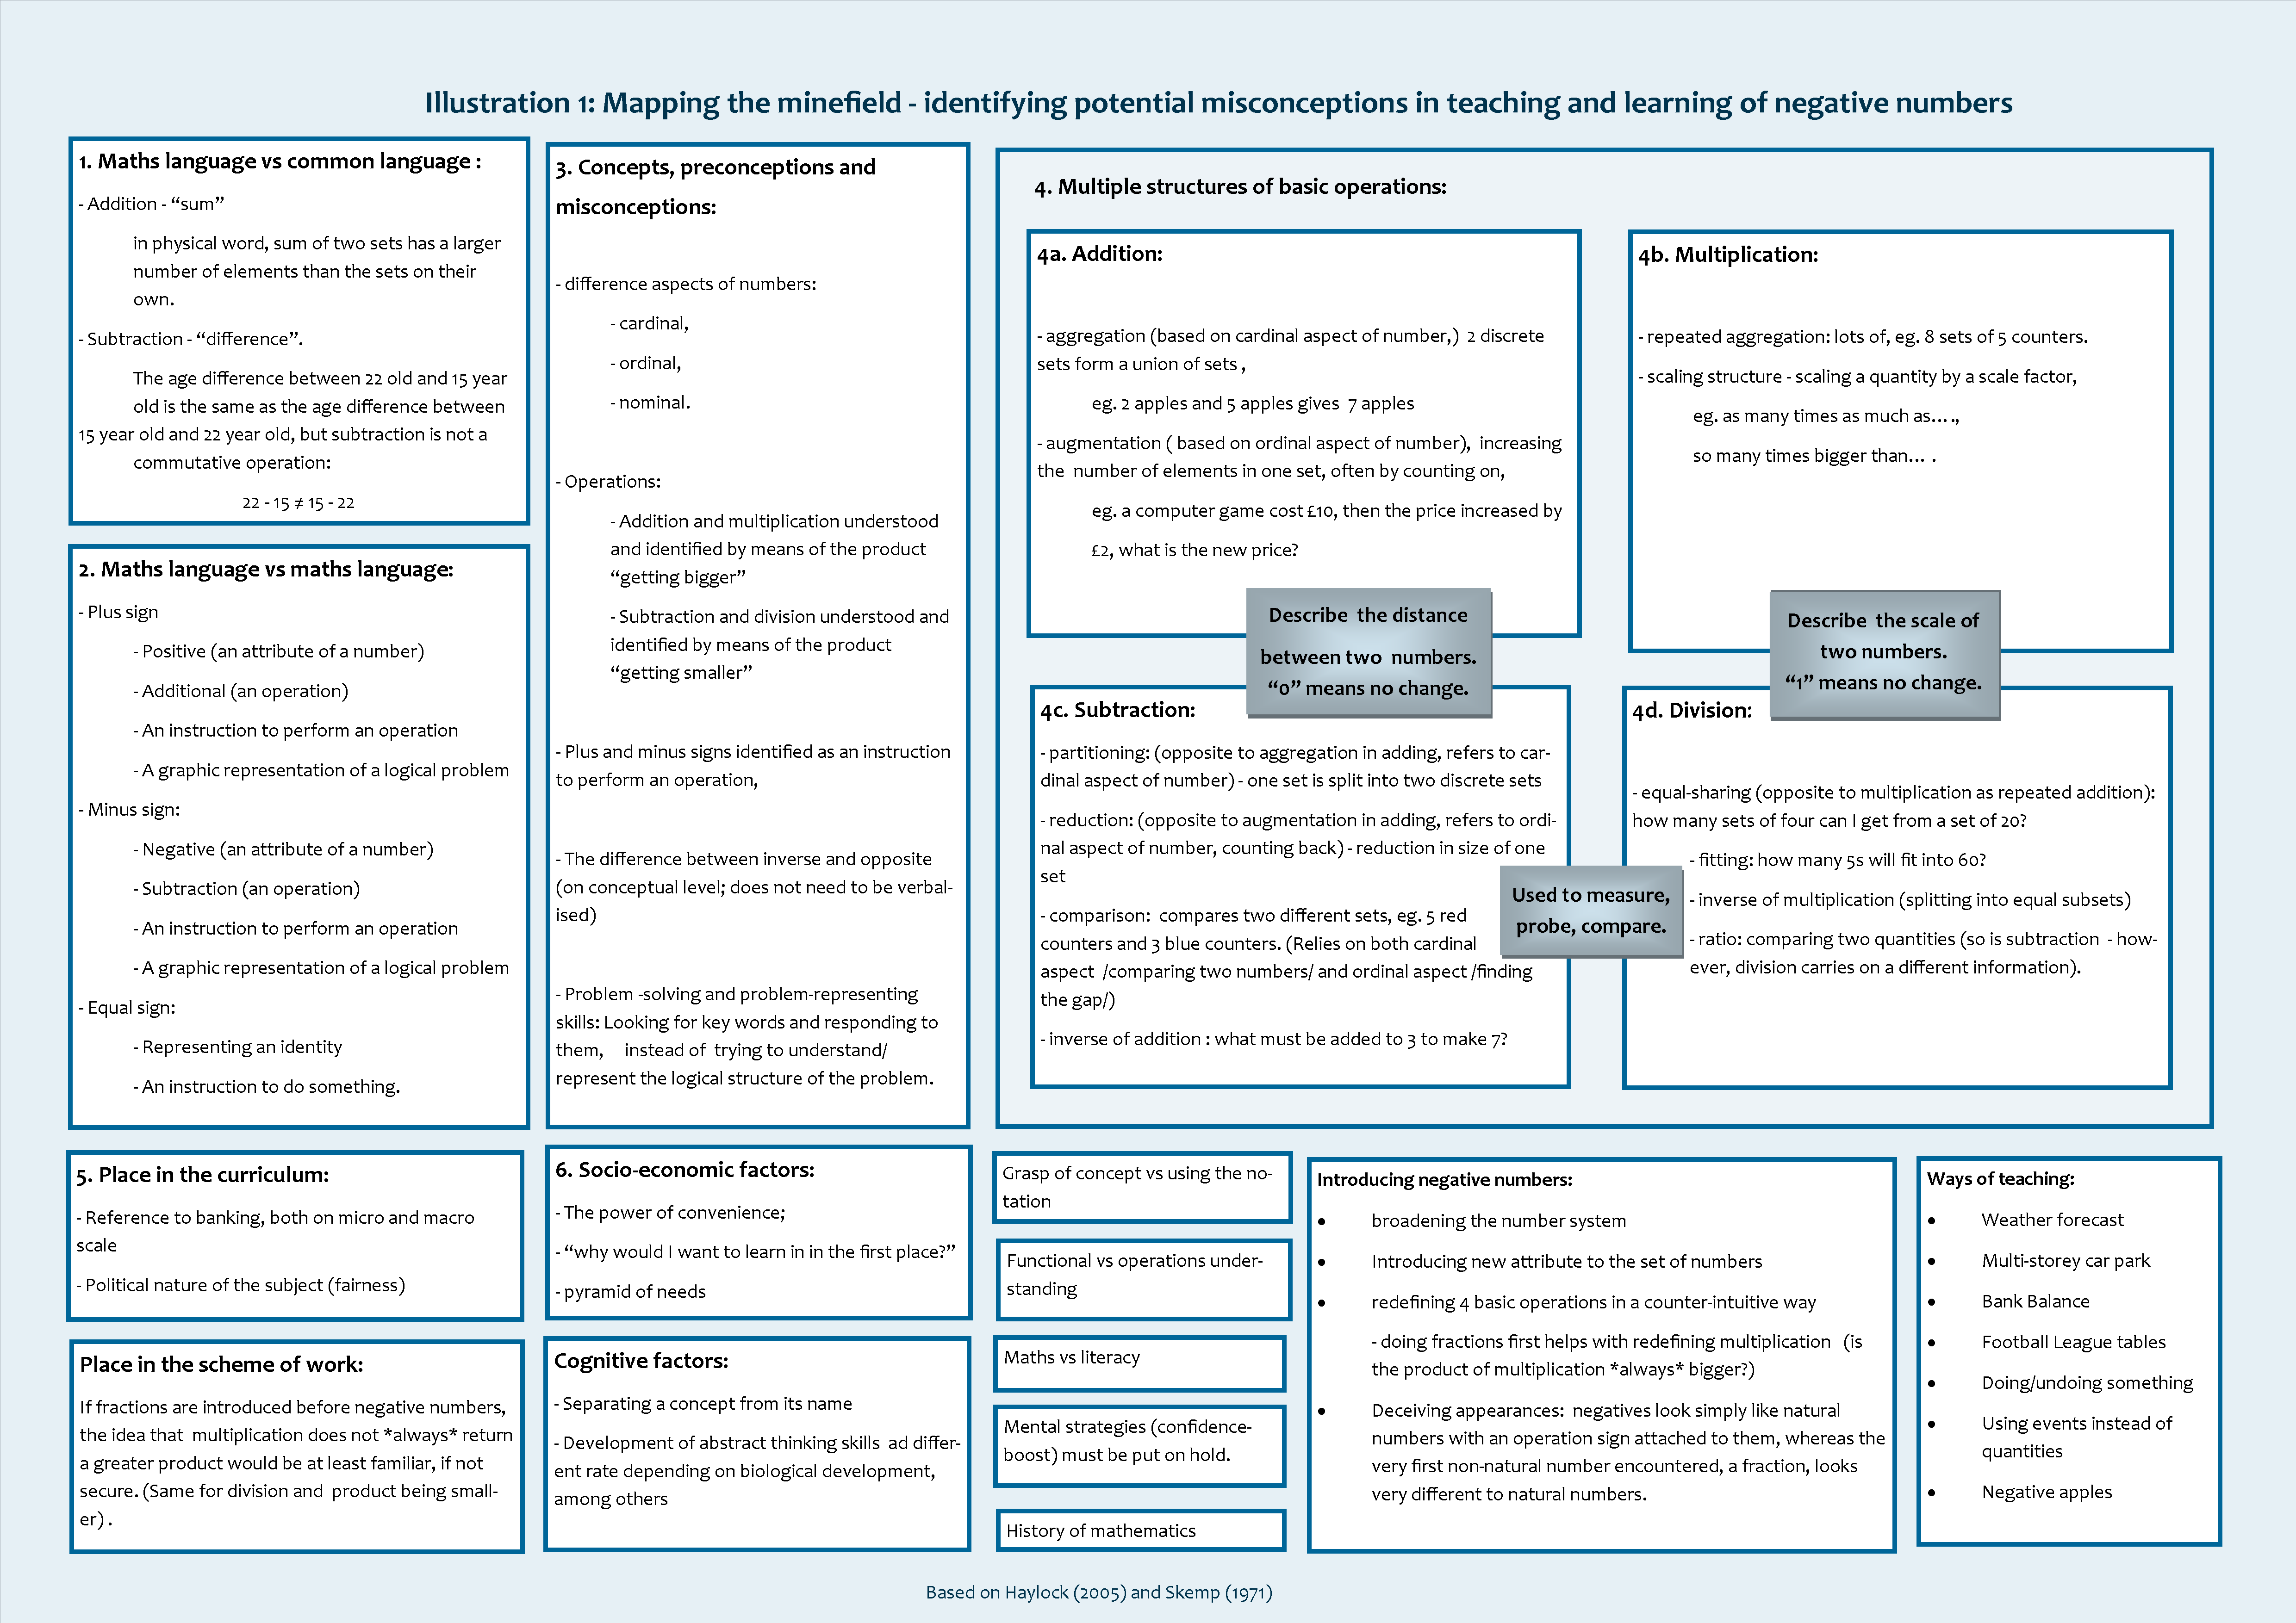
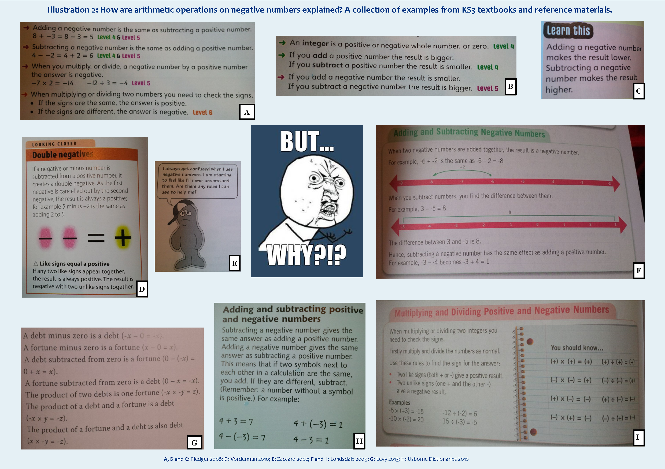

as opposite to operational understanding, which would simply require memorising the rules of arithmetic operations on integers (Skemp 1971, Grayson 2004)
like temperature, depth below sea level or multi-storey buildings
Representing numbers as vectors would be beneficial if students were to progress to physics and mechanics in their further studies, but perhaps KS3 is too early to consider this.
Note: this method is based on presumption that multiplication of a negative and a positive number has been already covered and proven by any of the previous methods.

